**Goliath License Key and Inventory Counts**

After applying your license key you received from Goliath, you can review your license counts to understand what your key give you access to.

**To view the license counts**

1. Log in to the Goliath Performance Monitor interface.
2. Go to **Settings** and click **Version & License Count.** A dialog similar to the following opens.  
   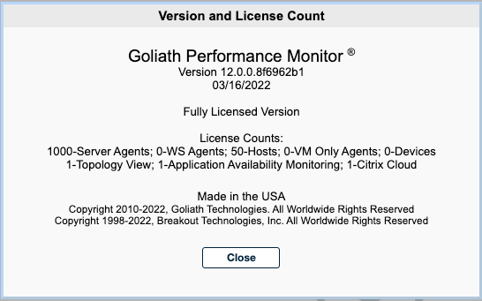
3. Review the information in the **License Counts**section. Details are described below.

**License Counts Descriptions**

|  |  |
| --- | --- |
| **Count** | **Description** |
| Server Agents | The number of Citrix Role server, Citrix XA/XD, Physical Machines, Hyper-V hosts/VMs, Master Agents, Application Availability Monitor endpoints and other license types. |
| WS Agents | The number of machines with a workstation OS that are not connected to a hypervisor API. |
| Hosts | The number of Citrix and/or VMware hosts. |
| VM Only Agents | The number of Citrix or VMware virtual machine agents purchased with the hypervisor license. |
| Devices | The number of network elements utilizing SNMP/SYSLOG or PING monitoring only. |
| Topology View | If set to 1, the Topology view is enabled. If set to 0, Topology is not licensed. |
| Application Availability Monitor. | If set to 1, Application Availability Monitor (GAAM) is enabled. If set to 0, Application Availability Monitor is not licensed. |
| Citrix Cloud | If set to 1, Citrix Cloud support is enabled. If set to 0, Citrix Cloud support is not licensed. |

The devices discovered and imported to your inventory may differ from what you are licensed to monitor. To review your inventory and understand your counts, use the **Inventory** page. The counts are displayed in the bottom bar of the interface page, as seen in the image below.

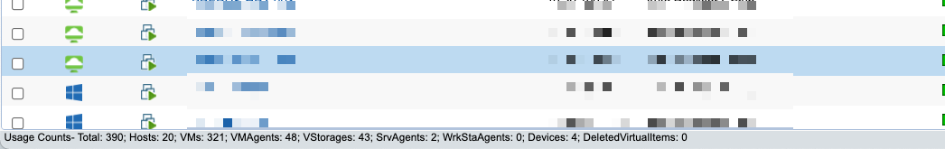

**Note**: agent counts include active and disconnected agents.

**Inventory Count Descriptions**

|  |  |
| --- | --- |
| **Count** | **Description** |
| Total | The total number of all items in inventory. |
| Hosts | Number of Citrix and/or VMware hosts being monitored. |
| VMs | The number of Citrix or VMware virtual machines from the hypervisor API. |
| VMAgents | Number of virtual machines from the Citrix or VMware hypervisor API that have an agent deployed. |
| VStorages | Virtual Storage. Number of datastores added from the Citrix and/or VMware hypervisor API. |
| SvrAgents | Server agents. Number of machines with an agent deployed that have a server OS that are not connected to a Citrix or VMware hypervisor API. |
| WrkStaAgents | Workstation Agents. Number of machines with an agent deployed that have a workstation OS that is not connected to a Citrix or VMware hypervisor API. |
| Devices | The number of machines and/or devices without an agent that are not connected to a Citrix or VMware hypervisor API. |
| DeletedVirtualItems | No longer used. Will be removed in future update. |